# South Dakota School of Mines & Technology

# Database Management Systems, Spring 2022

CSC 484-M01

Final Project Report

Zoe Millage

**1. INTRODUCTION**

This document provides a detailed report on the CSC 484 Final Project. In this case, the project is a basic role-playing game. The project was undertaken by Zoe Millage.

**2. FUNCTIONAL DEPENDENCIES**

Below is a table showing all the dependencies for the final tables. These dependencies were used in the normalization process.

Stats (id, name, playerId, baseHp, currHp, baseSp, currSp, atk, mAtk, def, mDef, crit, eva, lvl, exp, skillList)

|  |  |
| --- | --- |
| Depenency | Dependency type |
| id → name, baseHp, baseSp, atk, mAtk, def, mDef, crit, eva, skillList | (Primary key) |

Heroes (id, playerId, maxHp, currHp, maxSp, currSp, exp, lvl)

|  |  |
| --- | --- |
| Depenency | Dependency type |
| id, playerId → maxHp, currHp, maxSp, currSp, exp, lvl | (Primary Key) |

Enemies (id, expYield)

|  |  |
| --- | --- |
| Depenency | Dependency type |
| id, playerId, version → maxHp, currHp, expYield | (Primary Key) |

Items (id, name, hpRec, spRec, price, description)

|  |  |
| --- | --- |
| Depenency | Dependency type |
| id, playerId → name, hpRec, spRec, price, description | (Primary Key) |

ItemQuantity (id, playerId, quantity)

|  |  |
| --- | --- |
| Depenency | Dependency type |
| id, playerId → quantity | (Primary Key) |

Player (id, name)

|  |  |
| --- | --- |
| Depenency | Dependency type |
| id → name | (Primary Key) |

Skills (id, name, cost, atk, mAtk, crit, exp )

|  |  |
| --- | --- |
| Depenency | Dependency type |
| id → name, cost, ark, mAtk, crit, exp | (Primary Key) |

These dependencies do not account for derived attributes. For example, maxHp in Heroes is derived from lvl and from baseHp in Stats. currHp depends on maxHp.

**3. NORMALIZATION**

Below is a version of the relations in unnormalized form (UNF).













The next set of tables are in at least first normal form (1NF). Each tuple with multiple entries in an attribute has been split into individual tables. Because only Stats and Items are affected by this change, only those tables are shown here.







These are the dependencies for the current set of relations.

Stats (id, name, playerId, baseHp, currHp, baseSp, currSp, atk, mAtk, def, mDef, crit, eva, lvl, exp, skillList)

|  |  |
| --- | --- |
| Depenency | Dependency type |
| id, playerId → name, baseHp, currHp, baseSp, currSp, atk, mAtk, def, mDef, crit, eva, lvl, exp, skillList | (Primary key) |
| id → name, baseHp, baseSp, atk, mAtk, def, mDef, crit, eva, skillList | (Full dependency) |
| playerId → currHp, currSp, lvl, exp | (Transitive dependency) |

Items (id, playerId, name, hpRec, spRec, price, description, quantity)

|  |  |
| --- | --- |
| Depenency | Dependency type |
| id, playerId → name, hpRec, spRec, price, description, quantity | (Primary Key) |
| id → name, hpRec, spRec, price, description | (Full dependency) |
| playerId → quantity | ((Transitive dependency)) |

Player (id, name)

|  |  |
| --- | --- |
| Depenency | Dependency type |
| id → name | (Primary Key) |

Skills (id, name, cost, atk, mAtk, crit, exp )

|  |  |
| --- | --- |
| Depenency | Dependency type |
| id → name, cost, ark, mAtk, crit, exp | (Primary Key) |

Because these tables have no partial dependencies, the 1NF form for these tables is also the second normal form (2NF).

In third normal form (3NF), all transitive dependencies are removed. The final relations, which are at least in 3NF, are below. The updated dependencies can be found in section 2.

 





maxHp and maxSp were added to the heroes and Enemies table to save processing power. In the previous form, currHp would be derived using baseHp and lvl. Making maxHp its own attribute allows for fewer calculations between multiple relations. Version was added to the Enemies relation allows a user to battle multiple of the same enemy at a time.

**4. APPLICATION IMPLEMENTATION DETAILS**

An application that uses this database was envisioned as a turn-based role-playing game with a variety of starting characters to use by multiple users. The database consists of seven relations: Stats, Heroes, Enemies, Skills, Items, ItemQuantity, and Player. The attributes of each relation can be found above in sections 2 and 3. When a player views their heroes’ stats, they are shown a view with each hero’s current and maximum health points(HP) and skill points(SP), attack(atk), magic attack(mAtk), defense(def), magic defense(mDef), critical hit rate(crit), evasion rate(eva), level (lvl), and experience points(exp). If they view their items, they are given the name, description, and quantity of all items they own. When entering a battle, the players can see their heroes’ names, max and current HP, max and current SP, and the names of the current enemies. While not shown, the enemies’ SP and HP are also monitored during battles. The list of a hero’s skills can be seen with a different menu. The screenshots below show the code for creating and populating the Stats table.

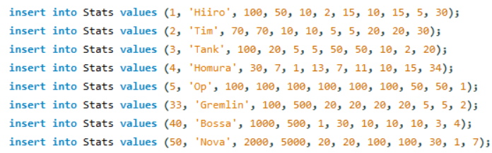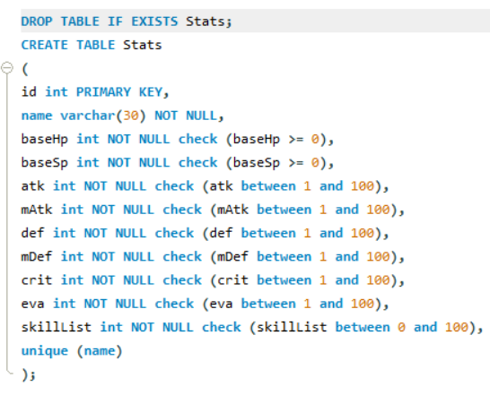

**5. WORKFLOW/DEMO**

This section will overview the process that would be undertaken in the application using the database.

When the application starts, the user would be welcomed and then asked if they had played the game before. If they had, they would be prompted for their player id until they gave a valid one or they cancel. Otherwise, the app would ask the user for a username, then they would be assigned an id, added to the Players relation, then given their id and told to remember or save it.

If this is the first time the game had been played, the user would be taken to a menu where they could view all available heroes, directly choose which heroes to use for the rest of the game, be given a set of random heroes from the list, or exit the program. Each player can have between 1 and 4 heroes. In this menu, checking the heroes displays the id, name, level, base HP, base SP, attack, magic attack, defense, magic defense, critical hit chance, and evade chance.

Once the user has a set of heroes, they would be taken to a different menu where they could view their heroes’ statuses, view their items, initiate a battle, or exit the program. Viewing heroes in this menu displays the name, level, current and maximum HP, current and maximum SP, attack, magic attack, defense, magic defense, critical hit chance, and evade chance. Checking the items would display the item name, description, and quantity owned.

When initiating a battle, the user can see the name of their heroes and the enemies, and the current hp of their heroes. In all menus where the heroes appear, a skill list would be accessible. This would show the name, description, and cost of the skill.

In battle, when a skill is selected, a target can be chosen (this includes your heroes, especially in the case of healing skills). After you chose your actions, your heroes would perform their skills. Then, the enemy would do the same. The battle ends when the HP of all characters on one side of the battle falls to zero.

After a battle ends, the user would be brought back to the second menu.

**6. FUTURE DEVELOPMENT**

If this program was created and improved upon in the future, several improvements can be made:

* Modify the player table such that there is a password, and implement proper login functionality
* Add status effects for more in-depth strategy
* Add equipment and/or permanent stat-increasing items for higher customizability of the heroes
* Add more characters
* Add more items
* Add shop functionality so the price attribute of items has a purpose
* Modify the enemy table so they can drop items
* Add image functionality so the characters have more than just a name to identify them and the app has better appeal in general
* Add music and sound effects along with applicable settings to make the game more engaging